Sentiment Analysis

Phase 1 – Data Understanding

1.1 Objective
The objective of Phase 1 is to understand the dataset before performing text preprocessing and feature representation. This includes examining the dataset structure, identifying the input and target variables, checking the sentiment distribution, and analyzing the characteristics of the movie reviews.

1.2 Dataset Description
The project uses the IMDb Movie Reviews Dataset, which contains movie reviews along with their corresponding sentiment labels.
Each review belongs to one of two sentiment classes:
- Positive
- Negative
The dataset is used to develop a binary sentiment classification system that predicts whether a given movie review expresses a positive or negative sentiment.
After removing unusable records, the dataset contains 49,582 reviews.

Dataset Features
Feature | Description
review | Original movie review text
sentiment | Sentiment label of the review
cleaned_review | Preprocessed/tokenized version created during Phase 2
The original dataset also contained an index column, which was not useful for sentiment prediction.

1.3 Dataset Shape
The dataset contains:
49,582 rows × 4 columns
The columns available in your working DataFrame are:
- review
sentiment
cleaned_review
The important columns for the machine learning task are:
- review → input feature
- sentiment → target variable
cleaned_review is generated later during the preprocessing phase.

1.4 Target Variable
The target variable is:
- sentiment
It contains two classes:
- positive
negative
Therefore, this project is a binary text classification problem.
The model's task is:
Movie Review
↓
Sentiment Classification
↓
Positive / Negative

1.5 Class Distribution
The dataset contains approximately equal numbers of positive and negative reviews.
Sentiment | Count | Percentage
Positive | 24,791 | 50%
Negative | 24,791 | 50%
Total | 49,582 | 100%
This indicates that the dataset is balanced with respect to the target classes.
Therefore, significant class-imbalance handling was not required for this project.

1.6 Train, Validation and Test Split
The dataset was divided into three subsets:
Dataset | Number of Reviews
Training | 34,705
Validation | 7,439
Test | 7,438
Total | 49,582
The purpose of each dataset is different:

Training Dataset
Used to train the neural network models and learn patterns from the reviews.

Validation Dataset
Used during model development to monitor performance and tune hyperparameters.

Test Dataset
Used only for the final evaluation of the selected model on previously unseen reviews.
The test dataset was kept separate from the model-tuning process to obtain an unbiased estimate of final model performance.

1.7 Review Length Analysis
The review length was analyzed to understand how long the movie reviews are.
The project found:
Maximum review length ≈ 2470 words
Median review length ≈ 173 words
The difference between the median and maximum review length shows that some reviews are considerably longer than the typical review.
This analysis was useful when deciding the maximum sequence length during the feature representation phase.
Later, a maximum sequence length of:
MAX_LEN = 200
was used for the deep learning models.
Reviews longer than this limit were truncated, while shorter reviews were padded.

1.8 Initial Observations
The following observations were made during Phase 1:
- The dataset contains 49,582 movie reviews.
- The target variable contains two classes: positive and negative.
- The classes are approximately balanced.
- The reviews have variable lengths.
- Some reviews are significantly longer than the typical review.
- The raw review text cannot be directly given to the neural network models.
- Therefore, text preprocessing and feature representation are required before model training.
Visualization

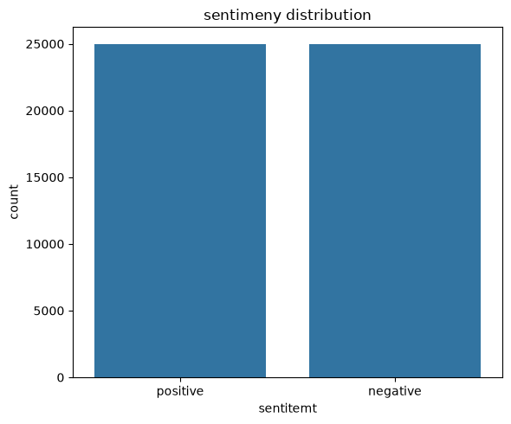

Fig 1 Sentiment Distribution

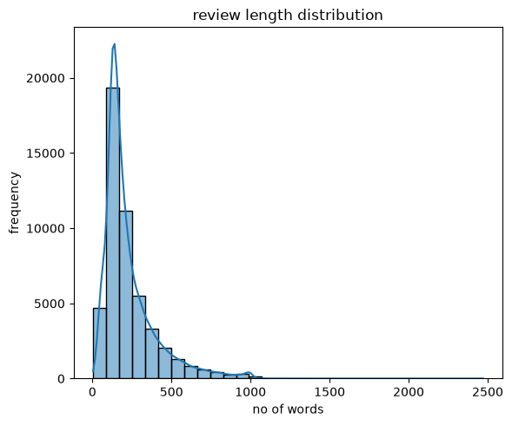

Fig 2 Review Length Distribution
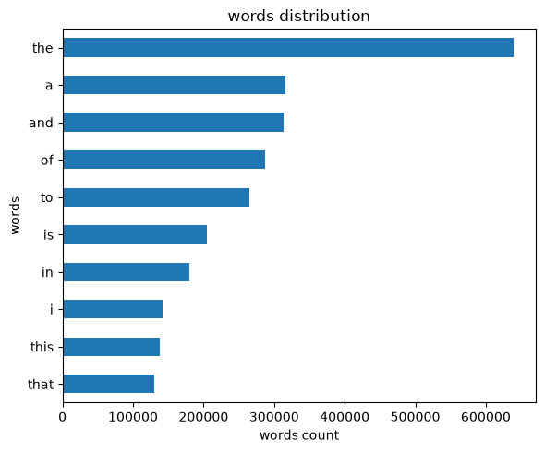

Fig 3 Words Distribution

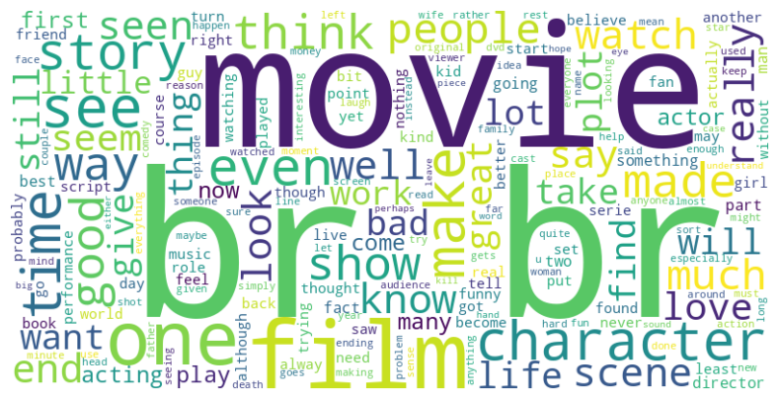

Fig 4 Words Cloud

1.9 Phase 1 Conclusion
In Phase 1, the IMDb movie review dataset was examined to understand its structure, sentiment distribution, and review-length characteristics. The dataset contains 49,582 reviews with a balanced distribution between positive and negative sentiments. The reviews vary considerably in length, making text preprocessing and sequence-length selection important for subsequent model development. Based on these observations, the dataset was prepared for the next phase, Text Preprocessing, where the raw reviews were cleaned and converted into a suitable format for machine learning.

Phase 2 – Text Preprocessing

2.1 Objective
The raw IMDb reviews contain text in a form that cannot be directly used by machine learning models. Therefore, the objective of this phase is to clean and transform the reviews into a consistent format suitable for feature extraction and deep learning.
The preprocessing pipeline used in this project is:
Raw Review
↓
Lowercase
↓
Remove HTML Tags
↓
Remove Punctuation
↓
Remove Stopwords
↓
Tokenization
↓
Cleaned Review

2.2 Inspecting the Raw Dataset
Before preprocessing, the dataset was examined to understand the available columns and review format.
CODE :
df.head()
The dataset contains columns such as:
review
sentiment
The review column contains the original movie review, while sentiment contains the target label.
For example:
Review:
"One of the other reviewers has mentioned that..."
Sentiment:
positive

2.3 Checking Missing Values
Missing values were checked before preprocessing.
CODE:
df.isnull().sum()
This step ensures that missing reviews or labels do not cause problems during later processing.
If missing values are present, they should be handled before continuing with tokenization and model training.

2.4 Removing Unnecessary Columns
The dataset contained an index-like column:
Unnamed: 0
This column does not contain meaningful information for sentiment prediction, so it was removed.
CODE:
df = df.drop(columns=["Unnamed: 0"])
After this, the important columns are:
review
sentiment

2.5 Converting Reviews to Lowercase
Text was converted to lowercase so that words with different capitalization are treated as the same word.
For example:
"Movie" → "movie"
"AMAZING" → "amazing"
"Good" → "good"
This reduces unnecessary variations in the vocabulary.
Example:
CODE:
df["review"] = df["review"].str.lower()

2.6 Removing HTML Tags
IMDb reviews can contain HTML tags such as:
<br />
These tags do not provide useful sentiment information, so they were removed.
A regular expression was used to remove HTML elements.
CODE:
import re
def remove_html(text):
return re.sub(r"<.*?>", "", text)
df["review"] = df["review"].apply(remove_html)
For example:
Before:
"This movie was great <br /><br /> I loved it."
After:
"This movie was great I loved it."

2.7 Removing Punctuation
Punctuation marks were removed from the reviews to simplify the text representation.
For example:
"movie!!!" → "movie"
"excellent, amazing." → "excellent amazing"
Example:
CODE:
import string
def remove_punctuation(text):
return text.translate(str.maketrans("", "", string.punctuation))
df["review"] = df["review"].apply(remove_punctuation)
This helps reduce unnecessary tokens in the vocabulary.

2.8 Removing Stopwords
Stopwords are common words such as:
the
is
a
an
and
of
to
Depending on the preprocessing strategy, these words may contribute relatively little to the classification task.
Stopword removal was therefore applied to reduce unnecessary words.
Conceptually:
"The movie was very good"
↓
"movie very good"
The exact stopword processing should match the preprocessing code used in your notebook.

2.9 Tokenization
After cleaning the text, each review was converted into individual words, known as tokens.
For example:
"this movie was really good"
becomes:
["this", "movie", "was", "really", "good"]
Tokenization is important because the deep learning models cannot directly understand raw text. The text must first be represented as numerical values.

2.10 Creating cleaned_review
The processed tokens were stored in a new column called:
cleaned_review
Your DataFrame therefore became approximately:
review | sentiment | cleaned_review
Original review | positive | ['wonderful', 'little', 'production', ...]
Original review | negative | ['basically', 'family', 'little', ...]
This column was subsequently used for feature representation.

2.11 Label Encoding
The sentiment labels were converted from text labels into numerical values.
The original labels were:
positive
negative
For binary classification, they were encoded as:
negative → 0
positive → 1
The encoded target was stored as y_train_en, y_val_en, and y_test_en.
This allows the neural network to work with numerical target values.

2.12 Train, Validation and Test Data
The data was separated into:
Training
Validation
Testing
Your final shapes were:
X_train → 34,705
X_val → 7,439
X_test → 7,438
and the corresponding target arrays have the same number of samples.
The split ensures that the model is trained, tuned, and finally evaluated on separate data.

2.13 Important Preprocessing Output
After preprocessing, the important data structure was:
review
sentiment
cleaned_review
And the machine-learning pipeline became:
Raw Review
↓
Cleaned Review
↓
Tokenization
↓
Integer Encoding
↓
Padding
↓
Deep Learning Model

2.14 Phase 2 Conclusion
In Phase 2, the raw IMDb movie reviews were transformed into a clean and machine-readable format. The reviews were converted to lowercase, HTML tags and unnecessary punctuation were removed, stopwords were handled, and the reviews were tokenized. A cleaned_review column was created to store the processed text. The sentiment labels were also converted into numerical values, with negative represented as 0 and positive as 1. The resulting data was divided into training, validation, and test sets, preparing it for feature representation in Phase 3.

Phase 3 – Feature Representation

3.1 Objective
The objective of Phase 3 is to convert the cleaned textual reviews into numerical representations that can be processed by machine learning and deep learning models.
In this project, the following feature-representation techniques were explored:
- Tokenization + Integer Encoding
- Padding
- TF-IDF
- Word Embedding
- Trainable Embedding Layer
The overall process is:
Cleaned Review
↓
Tokenization
↓
Integer Encoding
↓
Padding
↓
┌───────────────┬────────────────┐
↓ ↓ ↓
TF-IDF Word Embedding Trainable Embedding
↓ ↓ ↓
ML/ANN Neural Models Neural Models

3.2 Tokenization and Integer Encoding
Neural networks cannot directly process words such as:
"movie was excellent"
Therefore, the words were converted into numerical integer IDs.
A tokenizer was created with a vocabulary size of 20,000.
from tensorflow.keras.preprocessing.text import Tokenizer
VOCAB_SIZE = 20000
tokenizer = Tokenizer(num_words=VOCAB_SIZE)
tokenizer.fit_on_texts(x_train)
The tokenizer learns a vocabulary from the training reviews and assigns an integer to each word.
For example:
movie → 25
excellent → 143
good → 56
bad → 78
The reviews were then converted into sequences:
x_trainseq = tokenizer.texts_to_sequences(x_train)
x_valseq = tokenizer.texts_to_sequences(x_val)
x_testseq = tokenizer.texts_to_sequences(x_test)
This produces variable-length integer sequences.
For example:
"this movie is good"
might become:
[15, 25, 8, 56]

Important
The tokenizer was fit only on the training data:
tokenizer.fit_on_texts(x_train)
The validation and test data were only transformed using the already learned vocabulary.
This prevents information from the validation/test sets from leaking into the training process.

3.3 Sequence Padding
The generated sequences have different lengths because movie reviews are not all the same length.
For example:
Review 1 → [15, 25, 8, 56]
Review 2 → [12, 45, 67, 89, 21, 34, 76]
Review 3 → [8, 25]
Neural networks require inputs with a consistent shape.
Therefore, a maximum sequence length of:
MAX_LEN = 200
was selected.
Padding was performed using:
from tensorflow.keras.preprocessing.sequence import pad_sequences
x_train_pad = pad_sequences(
x_trainseq,
maxlen=MAX_LEN,
padding="post",
truncating="post"
)
x_val_pad = pad_sequences(
x_valseq,
maxlen=MAX_LEN,
padding="post",
truncating="post"
)
x_test_pad = pad_sequences(
x_testseq,
maxlen=MAX_LEN,
padding="post",
truncating="post"
)
The resulting shapes were:
X_train: (34705, 200)
X_val: (7439, 200)
X_test: (7438, 200)

Padding strategy
padding="post" means zeros are added at the end of shorter sequences.
truncating="post" means reviews longer than 200 tokens are truncated from the end.

3.4 TF-IDF Representation
TF-IDF (Term Frequency–Inverse Document Frequency) was also used to represent the reviews numerically.
Unlike integer encoding, TF-IDF represents each document using numerical weights based on the importance of words within the dataset.
The following configuration was used:
from sklearn.feature_extraction.text import TfidfVectorizer
tfidf = TfidfVectorizer(
max_features=20000,
ngram_range=(1, 2)
)
Here:
- max_features=20000 → maximum of 20,000 features
- ngram_range=(1,2) → both unigrams and bigrams are considered
For example:
"very good movie"
can generate:
very
good
movie
very good
good movie
The vectorizer was fitted on the training data:
x_train_tfidf = tfidf.fit_transform(x_train)
x_val_tfidf = tfidf.transform(x_val)
x_test_tfidf = tfidf.transform(x_test)
The resulting shapes were:
X_train TF-IDF: (34705, 20000)
X_val TF-IDF: (7439, 20000)
X_test TF-IDF: (7438, 20000)
Again, the vectorizer was fit only on the training data and then used to transform validation and test data.

3.5 TF-IDF Baseline Results
The TF-IDF representation produced the following validation performance:
Metric | Score
Accuracy | 90.09%
Precision | 88.97%
Recall | 91.62%
F1 Score | 90.27%
These results provided a strong baseline for comparison with the deep learning approaches.
The F1 score was:
90.27%
which indicates a good balance between precision and recall.

3.6 Word Embedding
Word embeddings represent words as dense numerical vectors rather than assigning each word a single integer.
For example, instead of:
good → 56
an embedding can represent good using a vector such as:
good → [0.21, -0.14, 0.73, ...]
with a predefined embedding dimension.
Words with similar meanings can have similar vector representations.
For this project, the padded integer sequences were used as the input to the embedding-based neural network models.
The input shape was:
(34705, 200)
with:
VOCAB_SIZE = 20000
MAX_LEN = 200

3.7 Trainable Embedding Layer
A trainable embedding layer was used to learn word representations directly from the IMDb sentiment dataset.
The basic structure was:
Integer Sequence
↓
Embedding Layer
↓
Dense Vector Representation
↓
Neural Network
↓
Sentiment
The embedding layer receives integer word IDs and learns a vector representation for each word during model training.
For example:
Input:
[15, 25, 8, 56, ...]
↓
Embedding Layer
↓
200 × Embedding Dimension
The embedding representation was then passed to subsequent neural-network layers.

3.8 Embedding-Based Model Result
The embedding-based approach achieved:
Metric | Score
Accuracy | 85.33%
Precision | 84.62%
Recall | 86.50%
F1 Score | 85.55%
Compared with the TF-IDF baseline:
TF-IDF F1 = 90.27%
Embedding F1 = 85.55%
Therefore, TF-IDF performed better at this stage.
However, the integer sequences and embedding representation were still important because they formed the input representation used for the ANN, RNN, LSTM, GRU and BiLSTM models in Phase 4.

3.9 Feature Representation Comparison
Representation | Train Shape | Validation Shape | Test Shape
TF-IDF | (34705, 20000) | (7439, 20000) | (7438, 20000)
Padded Sequences | (34705, 200) | (7439, 200) | (7438, 200)

Main difference
TF-IDF
Review → 20,000-dimensional sparse vector
Integer Encoding + Padding
Review → sequence of 200 integer IDs
The padded sequences are particularly suitable for neural networks because the embedding and recurrent layers can process the sequence of word IDs.

3.10 Why Padding Was Used for Deep Learning
The final deep-learning input was:
X_train = (34705, 200)
X_val = (7439, 200)
X_test = (7438, 200)
This means:
- 34,705 training reviews
- 7,439 validation reviews
- 7,438 test reviews
- Each review is represented using 200 token positions
These padded sequences were subsequently used for the deep learning models in Phase 4.

3.11 Phase 3 Conclusion
In Phase 3, the cleaned reviews were converted into numerical representations suitable for machine learning and deep learning. Tokenization and integer encoding were used to convert words into numerical IDs, followed by padding to a fixed sequence length of 200. TF-IDF with 20,000 features and unigram-bigram representation was also implemented and achieved an F1 score of 90.27%. An embedding-based representation achieved an F1 score of 85.55%. Although TF-IDF provided a strong baseline, padded integer sequences with an embedding layer were selected for the deep learning models because they allow neural networks to learn contextual word representations.

Phase 4 – Deep Learning Models

4.1 Objective
The objective of Phase 4 is to develop and compare different deep learning architectures for binary sentiment classification.
The padded integer sequences generated in Phase 3 were used as the input to the neural network models.
The following five architectures were implemented:
- ANN – Artificial Neural Network
- RNN – Recurrent Neural Network
- LSTM – Long Short-Term Memory
- GRU – Gated Recurrent Unit
- BiLSTM – Bidirectional LSTM
The models were trained to classify movie reviews into:
0 → Negative
1 → Positive

4.2 Input Data
The deep learning models used the padded sequences created in Phase 3.
X_train shape → (34705, 200)
X_val shape → (7439, 200)
X_test shape → (7438, 200)
The main parameters were:
VOCAB_SIZE = 20,000
MAX_LEN = 200
Therefore, each review was represented as a sequence of 200 integer tokens.

4.3 ANN Model
The first deep learning architecture implemented was a basic Artificial Neural Network (ANN).
The general architecture was:
Input Sequence
↓
Embedding
↓
Global Average Pooling
↓
Dense Layer
↓
Dropout
↓
Output Layer
↓
Sigmoid
↓
Positive / Negative
The embedding layer converts the integer word IDs into dense vectors.
The Global Average Pooling layer reduces the sequence representation into a fixed-size vector before passing it to the dense layers.

Training
The ANN was trained using the training dataset while the validation dataset was used to monitor validation performance.
The model generated predictions on the validation/test data and was evaluated using:
- Accuracy
- Precision
- Recall
- F1 Score
- ROC-AUC

4.4 Simple RNN
The second architecture was a Simple Recurrent Neural Network (RNN).
RNNs are designed to process sequential data by maintaining information from previous time steps.
The architecture can be represented as:
Integer Sequence
↓
Embedding
↓
Simple RNN
↓
Dense Layer
↓
Output
↓
Sigmoid
Unlike the ANN, the RNN processes the review as a sequence and can use information from earlier words while processing later words.

4.5 LSTM
The third architecture was Long Short-Term Memory (LSTM).
LSTM is a specialized recurrent neural network designed to handle long-term dependencies in sequential data.
Its architecture was:
Integer Sequence
↓
Embedding
↓
LSTM
↓
Dense Layer
↓
Output
↓
Sigmoid
LSTM uses gates to control the information that should be:
- remembered
- forgotten
- passed to the next time step
This makes it more effective than a basic RNN for many long-sequence problems.

4.6 GRU
The fourth architecture was Gated Recurrent Unit (GRU).
The architecture was:
Integer Sequence
↓
Embedding
↓
GRU
↓
Dense Layer
↓
Output
↓
Sigmoid
GRU is another gated recurrent architecture.
Compared with LSTM, GRU has a simpler gating structure and generally contains fewer parameters.
In this project, the GRU produced the best overall final performance.

4.7 Bidirectional LSTM
The fifth architecture was Bidirectional LSTM (BiLSTM).
Instead of processing the review only from beginning to end, BiLSTM processes the sequence in both directions.
┌──→ Forward LSTM ──→
Input Sequence ─┤
└──→ Backward LSTM ─→
↓
Combined Output
↓
Dense Layer
↓
Output
This allows the model to use information from both previous and following words when generating its representation.

4.8 Model Training
All models were trained using the training dataset.
The validation dataset was used during training to monitor the model's ability to generalize to unseen data.
The training process generated a training history containing values such as:
- Training accuracy
- Validation accuracy
- Training loss
- Validation loss
These histories were later used to analyze model learning behavior.

4.9 Model Evaluation
After training, predictions were generated and the models were evaluated using:

Accuracy
Measures the percentage of correctly classified reviews.

Precision
Measures how many reviews predicted as positive were actually positive.

Recall
Measures how many actual positive reviews were correctly identified.

F1 Score
Provides a balance between precision and recall.

ROC-AUC
Measures the model's ability to distinguish between the two sentiment classes across different classification thresholds.

4.10 Phase 4 Model Comparison
Your initial Phase 4 results were:
Model | Accuracy | Precision | Recall | F1 Score | AUC
ANN | 87% | 85% | 91% | 88% | 87%
RNN | 51% | 54% | 24% | 33% | 51%
LSTM | 87% | 85% | 89% | 87% | 87%
GRU | 87% | 87% | 89% | 88% | 87%
BiLSTM | 87% | 87% | 86% | 87% | 87%
These results show that the Simple RNN performed significantly worse than the other architectures.
The GRU, LSTM, ANN, and BiLSTM provided considerably better sentiment classification performance.

4.11 Model Saving
After training, the models were saved so that they could be reused without retraining.
The saved models can subsequently be used for:
- Testing
- Comparison
- Flask deployment
- Sentiment prediction
- Batch prediction
The GRU model was eventually selected as the primary model for deployment because it achieved the best final performance after model improvement.

4.12 Training History
The training history of each model was recorded during model fitting.
The history can be used to plot:

Accuracy Curve
Training Accuracy
vs
Validation Accuracy

Loss Curve
Training Loss
vs
Validation Loss
These plots help identify:
- Whether the model is learning
- Overfitting
- Underfitting
- Convergence behavior
These training-history plots are also useful for the Model Comparison section of the Flask application.

4.13 Phase 4 Conclusion
In Phase 4, five deep learning architectures—ANN, Simple RNN, LSTM, GRU, and BiLSTM—were implemented for sentiment classification. All models used the padded integer sequences generated during Phase 3. Each model was trained, evaluated, and compared using accuracy, precision, recall, F1 score, and ROC-AUC. The Simple RNN showed significantly lower performance compared with the other architectures. The recurrent architectures, particularly LSTM, GRU, and BiLSTM, demonstrated stronger classification performance. The models and training histories were saved for further analysis and model improvement in Phase 5.

Phase 5 – Model Improvement

5.1 Objective
The objective of Phase 5 is to improve the performance and generalization ability of the deep learning models developed in Phase 4.
Different hyperparameters and training strategies were experimented with to determine which configurations provided better sentiment classification performance.
The following techniques were investigated:
- Embedding dimension tuning
- Sequence length tuning
- Number of hidden units
- Dropout
- Recurrent dropout
- Batch normalization
- Optimizer comparison
- Learning-rate tuning
- Batch-size tuning
- Early stopping
- Learning-rate scheduling

5.2 Embedding Dimension Tuning
The embedding dimension determines the size of the numerical vector used to represent each word.
A larger embedding dimension can capture more information about word representations, but it also increases the number of model parameters and computational requirements.
Different embedding dimensions were experimented with to identify a suitable representation for the reviews.
The general structure was:
Integer-encoded words
↓
Embedding Layer
↓
Embedding Dimension
↓
Neural Network
The embedding dimension was treated as a hyperparameter and different configurations were evaluated based on validation performance.

Observation
The embedding dimension affects both the representation quality and the complexity of the model. An appropriate dimension was selected based on the experimental results rather than simply choosing the largest value.

5.3 Sequence Length Tuning
The original reviews have different lengths. Therefore, a fixed sequence length is required before they can be provided to the neural networks.
The initial configuration was:
MAX_LEN = 200
The padded data had the following shapes:
Training → (34705, 200)
Validation → (7439, 200)
Testing → (7438, 200)
Different sequence lengths were experimented with to determine whether shorter or longer sequences improved sentiment classification.

Observation
Sequence length represents a trade-off:
- Shorter sequences reduce computational cost but may remove useful information.
- Longer sequences retain more information but increase computational requirements and may introduce unnecessary information.
The selected sequence length was based on the observed model performance.

5.4 Number of Hidden Units
The number of hidden units controls the capacity of a neural network layer.
Different hidden-unit configurations were tested, including:
32 hidden units
128 hidden units
The purpose was to determine whether increasing the number of neurons improved the model's ability to learn sentiment-related patterns.

Observation
Increasing hidden units can allow a model to learn more complex patterns, but excessive model capacity can also increase the risk of overfitting.
Therefore, hidden units were selected based on validation performance.

5.5 Dropout Tuning
Dropout was tested as a regularization technique to reduce overfitting.
The experimented dropout rates included:
0.3
0.2
0.5
During training, dropout randomly disables a proportion of neurons.

Experimental Observation
The dropout experiments did not produce better results in this project.
In some experiments, the F1 score dropped significantly, with values around:
0.12
0.15
These results were substantially worse than the baseline models.
Therefore, the tested dropout configurations were not selected for the final model configuration.
This demonstrates that adding regularization does not automatically improve model performance; it must be validated experimentally.

5.6 Recurrent Dropout
Recurrent dropout was considered for recurrent architectures such as:
- RNN
- LSTM
- GRU
- BiLSTM
Recurrent dropout applies dropout to the recurrent connections of the network.
The purpose was to determine whether it could reduce overfitting while maintaining useful sequential information.

Observation
Since dropout experiments already resulted in significantly degraded performance, recurrent dropout was not adopted as a final configuration where it did not demonstrate a clear improvement.
For the ANN, recurrent dropout was not applicable because ANN does not contain recurrent connections.

5.7 Batch Normalization
Batch normalization was investigated as another model-improvement technique.
Its purpose is to normalize activations during training and potentially improve:
- Training stability
- Convergence
- Optimization
- Generalization
The technique was evaluated experimentally to determine whether it improved validation performance.

Observation
Batch normalization was considered as part of the model-improvement experiments, and the configuration was compared using the same evaluation metrics.

5.8 Optimizer Comparison
Different optimization algorithms were tested:
Adam
RMSprop
SGD
The optimizer controls how the model's weights are updated during training.

Adam
Adam adapts the learning rate for individual parameters and is commonly used for deep learning tasks.

RMSprop
RMSprop adapts the learning rate based on a moving average of squared gradients and can work well with recurrent networks.

SGD
Stochastic Gradient Descent updates model parameters using the gradient of the loss function.
The three optimizers were compared using validation performance.

Observation
The optimizer was treated as a hyperparameter, and the best-performing configuration was selected based on the experimental results.

5.9 Learning-Rate Tuning
The learning rate determines the size of each update made to the model's weights during optimization.
Different learning-rate values were tested to determine whether changing the learning rate improved convergence and model performance.
Conceptually:
Learning Rate
↓
Weight Update Size
↓
Training Behaviour
↓
Final Performance
A learning rate that is too high can cause unstable training, while a very low learning rate can result in slow learning.
The learning rate was therefore tuned experimentally.

5.10 Batch-Size Tuning
Batch size determines how many training samples are processed before the model updates its weights.
Different batch sizes were tested to evaluate their effect on training and validation performance.
Batch size can affect:
- Training speed
- Memory usage
- Optimization behaviour
- Model generalization
The most suitable batch-size configuration was selected based on experimental performance.

5.11 Early Stopping
Early stopping was used to prevent unnecessary training once the validation performance stopped improving.
The basic concept is:
Training
↓
Validation Performance
↓
Improvement?
↓
No improvement for several epochs
↓
Stop training
This helps reduce overfitting and avoids wasting computational resources on additional epochs that do not improve the model.
Early stopping was included as part of the model-improvement experiments.

5.12 Learning-Rate Scheduling
Learning-rate scheduling was also investigated.
Instead of keeping the learning rate constant throughout training, the learning rate can be adjusted based on the training progress.
The general idea is:
Initial Learning Rate
↓
Training
↓
Validation performance monitored
↓
Learning rate adjusted
↓
Continued training
This can help the model make larger updates during the early stages and smaller updates when approaching a better solution.

5.13 Model Improvement Strategy
The experiments followed a systematic approach:
Phase 4 Model
↓
Embedding Dimension
↓
Sequence Length
↓
Hidden Units
↓
Dropout
↓
Recurrent Dropout
↓
Batch Normalization
↓
Optimizers
↓
Learning Rate
↓
Batch Size
↓
Early Stopping
↓
Learning-Rate Scheduling
↓
Final Configuration
Each experiment was evaluated using the same performance metrics:
- Accuracy
- Precision
- Recall
- F1 Score
- ROC-AUC
This makes the experiments easier to compare.

5.14 Final Model Performance
After the model-development and improvement experiments, the final evaluation results were:
Model | Accuracy | Precision | Recall | F1 Score | ROC-AUC
ANN | 88.65% | 86.43% | 91.80% | 89.04% | 88.64%
RNN | 54.40% | 54.43% | 56.09% | 55.25% | 54.39%
LSTM | 86.91% | 87.17% | 86.66% | 86.92% | 86.91%
GRU | 89.90% | 88.63% | 91.64% | 90.11% | 89.90%
BiLSTM | 88.46% | 87.14% | 90.36% | 88.72% | 88.46%

Best Model
The GRU achieved the highest overall F1 score:
F1 Score = 90.11%
It also achieved:
Accuracy = 89.90%
Precision = 88.63%
Recall = 91.64%
ROC-AUC = 89.90%
Therefore, the GRU model was selected as the final model for deployment in the Flask application.

5.15 Phase 5 Conclusion
In Phase 5, several hyperparameters and training strategies were experimented with to improve the deep learning models. Embedding dimension, sequence length, hidden units, dropout, recurrent dropout, batch normalization, optimizers, learning rate, batch size, early stopping, and learning-rate scheduling were investigated. The experiments demonstrated that model improvement requires empirical evaluation because some techniques, such as the tested dropout configurations, resulted in substantially lower F1 scores. After comparing the different configurations, the GRU achieved the best final performance with an accuracy of 89.90%, F1 score of 90.11%, and ROC-AUC of 89.90%. Therefore, the GRU was selected as the final sentiment classification model for Flask deployment.

Phase 6 – Model Evaluation and Analysis

6.1 Objective
The objective of Phase 6 is to evaluate the trained sentiment classification models on the test dataset and analyze their performance using multiple evaluation metrics and visualizations.
The following models were evaluated:
- ANN
- RNN
- LSTM
- GRU
- BiLSTM
The models were loaded from their previously saved .keras files and evaluated using the unseen test dataset.

6.2 Loading the Test Dataset
The saved NumPy arrays containing the training, validation, and test data were loaded.
x_train = np.load(r"../data/cleaned/x_train.npy")
x_test = np.load(r"../data/cleaned/x_test.npy")
x_val = np.load(r"../data/cleaned/x_val.npy")
y_train = np.load(r"../data/cleaned/y_train.npy")
y_test = np.load(r"../data/cleaned/y_test.npy")
y_val = np.load(r"../data/cleaned/y_val.npy")
For final evaluation, the important datasets are:
x_test
y_test
The test dataset was not used for training and therefore provides an unbiased evaluation of the trained models.

6.3 Evaluation Metrics
A reusable function was created to calculate the major classification metrics.
def evaluation_metrics(y_true, y_pred):
accuracy = accuracy_score(y_true, y_pred)
precision = precision_score(y_true, y_pred)
recall = recall_score(y_true, y_pred)
f1 = f1_score(y_true, y_pred)
roc_auc = roc_auc_score(y_true, y_pred)
return accuracy, precision, recall, f1, roc_auc
The following metrics were calculated:

Accuracy
Measures the proportion of correctly classified reviews.

Precision
Measures how many reviews predicted as positive were actually positive.

Recall
Measures how many actual positive reviews were correctly identified.

F1 Score
Provides a balance between precision and recall.

ROC-AUC
Measures the ability of the classifier to distinguish between the two sentiment classes.

6.4 ANN Evaluation
The saved ANN model was loaded:
ann_model = keras.models.load_model(
r'../models/ann_model_lr.keras'
)
Predictions were generated using the test dataset:
y_pred = ann_model.predict(x_test)
y_pred = (y_pred >= 0.5).astype(int).ravel()
The probability output was converted into a binary prediction using a threshold of 0.5.
The ANN performance was then calculated using the evaluation function.

ANN Results
Metric | Score
Accuracy | 88.65%
Precision | 86.43%
Recall | 91.80%
F1 Score | 89.04%
ROC-AUC | 88.64%

6.5 RNN Evaluation
The saved RNN model was loaded and evaluated using the test dataset.
rnn_model = keras.models.load_model(
r'../models/rnn_model_lr1.keras'
)
Predictions were converted into binary classes using a 0.5 threshold.

RNN Results
Metric | Score
Accuracy | 54.40%
Precision | 54.43%
Recall | 56.09%
F1 Score | 55.25%
ROC-AUC | 54.39%
The RNN performed considerably worse than the other models.

6.6 LSTM Evaluation
The trained LSTM model was loaded:
lstm_model = keras.models.load_model(
r'../models/rnn_model_re2.keras'
)
Note: Although the saved filename is rnn_model_re2.keras, the notebook comments indicate that this saved model is the LSTM model.
The model was evaluated using the same test dataset and evaluation metrics.

LSTM Results
Metric | Score
Accuracy | 86.91%
Precision | 87.17%
Recall | 86.66%
F1 Score | 86.92%
ROC-AUC | 86.919

6.7 GRU Evaluation
The saved GRU model was loaded:
gru_model = keras.models.load_model(
r'../models/gru_early.keras'
)
The model was then evaluated on the test dataset.

GRU Results
Metric | Score
Accuracy | 89.90%
Precision | 88.63%
Recall | 91.64%
F1 Score | 90.11%
ROC-AUC | 89.90%
The GRU produced the best overall performance among the evaluated models.

6.8 BiLSTM Evaluation
The saved BiLSTM model was loaded:
bilstm_model = keras.models.load_model(
r'../models/bilstm_seq300.keras'
)
The model was evaluated using the test dataset.

BiLSTM Results
Metric | Score
Accuracy | 88.46%
Precision | 87.14%
Recall | 90.36%
F1 Score | 88.72%
ROC-AUC | 88.46

6.9 Confusion Matrix
A confusion matrix was generated for the models to understand their classification behaviour.
For example:
confusion_mat = confusion_matrix(y_test, y_pred)
The confusion matrix contains:
Predicted
Negative Positive
Actual Negative TN FP
Actual Positive FN TP
The matrix helps identify:
- Correctly classified negative reviews
- Correctly classified positive reviews
- Negative reviews incorrectly classified as positive
- Positive reviews incorrectly classified as negative
The confusion matrices were saved as image files for use in the Flask application.
For example:
plt.savefig(
r'../static/images/ann-cm.png',
dpi=300,
bbox_inches='tight'
)
Similar confusion-matrix images were generated for the other models.

6.10 GRU Training History
The training history of the selected GRU model was loaded from:
hyper_df = pd.read_csv(
r'../log/gru_early.csv'
)
The training history contains:
- Training accuracy
- Validation accuracy
- Training loss
- Validation loss

Accuracy Curve
The training and validation accuracy were plotted against epochs.
Training Accuracy
vs
Validation Accuracy
This allows us to observe how the model's accuracy changed during training.

Loss Curve
Training and validation loss were also plotted.
Training Loss
vs
Validation Loss
These plots help identify whether the model was:
- Learning properly
- Overfitting
- Underfitting
- Converging

6.11 ROC Curve
The ROC curve was generated specifically for the final GRU model.
Importantly, the ROC curve uses the probability predictions rather than the thresholded 0/1 predictions.
y_pred_prob = gru_model.predict(x_test).ravel()
fpr, tpr, thresholds = roc_curve(
y_test,
y_pred_prob
)
auc_score = roc_auc_score(
y_test,
y_pred_prob
)
The ROC curve plots:
True Positive Rate
vs
False Positive Rate
The GRU achieved:
ROC-AUC = 0.8990
This indicates that the GRU has strong ability to distinguish between positive and negative reviews.

6.12 Precision-Recall Curve
A Precision-Recall curve was also generated for the GRU.
precision, recall, thresholds = precision_recall_curve(
y_test,
y_pred_prob
)
ap_score = average_precision_score(
y_test,
y_pred_prob
)
The curve plots:
Precision
vs
Recall
The Average Precision score was used to summarize the precision-recall performance.
This provides an additional evaluation of the classifier, particularly across different classification thresholds.

Phase 7 – Model Comparison
Your notebook also contains the model-comparison section.

7.1 Objective
The objective of Phase 7 is to compare all trained models using the same evaluation metrics and identify the best-performing architecture.
The results were stored in a dictionary:
results = {
"MODEL": [],
"ACCURACY": [],
"PRECISION": [],
"RECALL": [],
"F1 SCORE": [],
"AUC": []
}
Each model's results were added using the performance() function.

7.2 Final Model Comparison
The final comparison is:
Model | Accuracy | Precision | Recall | F1 Score | AUC
ANN | 88.65% | 86.43% | 91.80% | 89.04% | 88.64%
RNN | 54.40% | 54.43% | 56.09% | 55.25% | 54.39%
LSTM | 86.91% | 87.17% | 86.66% | 86.92% | 86.91%
GRU | 89.90% | 88.63% | 91.64% | 90.11% | 89.90%
BiLSTM | 88.46% | 87.14% | 90.36% | 88.72% | 88.46%
The results were converted into a DataFrame:
df = pd.DataFrame(results)
and saved as:
df.to_csv(
r"../data/performance/result.csv",
index=False
)
This CSV can then be used by your Flask Model Comparison dashboard.

7.3 Best Model Selection
Based on the final test results, the GRU model was selected as the final model.
The GRU achieved:
- Accuracy: 89.90%
- Precision: 88.63%
- Recall: 91.64%
- F1 Score: 90.11%
- ROC-AUC: 89.90%
The F1 score is particularly important because it provides a balance between precision and recall.
Therefore:
GRU was selected as the final sentiment classification model for deployment.

7.4 Phase 6 & 7 Conclusion
In Phase 6, the trained ANN, RNN, LSTM, GRU, and BiLSTM models were evaluated on the unseen test dataset using accuracy, precision, recall, F1 score, and ROC-AUC. Confusion matrices, training-history curves, a ROC curve, and a Precision-Recall curve were also generated to analyze model performance in greater detail. In Phase 7, the evaluation results of all models were consolidated into a single comparison DataFrame and saved as a CSV file for use in the Flask application. Among the evaluated models, GRU achieved the highest overall performance with an accuracy of 89.90%, F1 score of 90.11%, and ROC-AUC of 89.90%. Therefore, the GRU model was selected as the final model for deployment.

Phase 8 – Model Interpretation

8.1 Objective
The objective of Phase 8 is to interpret the behavior of the trained sentiment classification model and understand how it performs on different types of reviews.
The interpretation focuses on:
- Important words contributing to sentiment.
- Correctly classified reviews.
- Misclassified reviews.
- Positive and negative language patterns.
- Model limitations.
- Effect of preprocessing and optimization.

8.2 Important Words Contributing to Sentiment
The model learns patterns from the words present in the training data to distinguish between positive and negative reviews.
Positive reviews generally contain words and expressions associated with:
- Good quality
- Enjoyment
- Excellent experience
- Positive opinions
- Recommendations
Negative reviews generally contain words and expressions associated with:
- Poor quality
- Disappointment
- Bad experience
- Negative opinions
- Criticism
The GRU model uses the sequence of words rather than simply checking individual words, allowing it to learn relationships between words within a review.

8.3 Correctly Classified Reviews
Correctly classified reviews are reviews where the predicted sentiment matches the actual sentiment.
These predictions indicate that the model has successfully learned the sentiment patterns present in the review.
For example:
Actual Sentiment Predicted Sentiment
Positive Positive
Negative Negative
A high number of correctly classified reviews contributes to the overall accuracy and F1 score of the model.

8.4 Misclassified Reviews
Misclassified reviews are reviews where the predicted sentiment is different from the actual sentiment.
For example:
Actual Sentiment Predicted Sentiment
Positive Negative
Negative Positive
Misclassification can occur when reviews contain:
- Mixed positive and negative opinions.
- Sarcasm.
- Negation.
- Ambiguous language.
- Complex sentence structures.
These reviews are more difficult for the model to classify correctly because their sentiment may not be clearly expressed.

8.5 Positive vs Negative Language Patterns
The model identifies different linguistic patterns associated with positive and negative sentiment.
Positive language patterns generally express:
- Satisfaction
- Appreciation
- Enjoyment
- Approval
Negative language patterns generally express:
- Dissatisfaction
- Criticism
- Disappointment
- Disapproval
The GRU architecture is useful for sentiment analysis because it processes text as a sequence and can learn contextual relationships between words.

8.6 Model Limitations
Although the GRU model achieved strong performance, some limitations remain.
The model may have difficulty with:
- Sarcastic reviews.
- Very short or ambiguous reviews.
- Reviews containing both positive and negative sentiments.
- Unusual or unseen words.
- Complex contextual meanings.
Therefore, a prediction from the model should be considered a classification result rather than a perfect understanding of the review.

8.7 Effect of Preprocessing and Optimization
Preprocessing plays an important role in the model's performance.
The reviews are converted into numerical sequences using the saved tokenizer and then padded to a fixed length of 200 tokens before being passed to the GRU model.
The same preprocessing procedure is also applied during batch prediction, ensuring that multiple reviews are converted into the format expected by the trained model.
The final GRU model was selected during the previous model-comparison phase and is used for deployment in the Flask application.

8.8 Conclusion
Phase 8 focused on interpreting the trained sentiment classification model rather than only evaluating its numerical performance.
The analysis examined important sentiment patterns, correctly and incorrectly classified reviews, positive and negative language patterns, and the limitations of the model. The effect of preprocessing was also considered, as tokenization and sequence padding ensure that the review text is converted into the required input format for the GRU model.

Phase 9 – Flask Sentiment Analysis Dashboard

9.1 Objective
The objective of Phase 8 is to develop an interactive Sentiment Analysis Dashboard using Flask.
The dashboard allows users to analyze customer reviews using the trained GRU sentiment classification model. It provides separate sections for dashboard, single review prediction, model comparison, analytics, batch prediction, and downloading prediction results.
app.py

9.2 Dashboard
The main dashboard displays the overall sentiment analysis project information.
The dashboard includes:
- Model performance results.
- Evaluation metrics of the trained models.
- Summary of the sentiment analysis system.
The performance data is loaded from result.csv and displayed on the dashboard page.
app.py
Dashboard Workflow
User Opens Application
↓
Dashboard Route (/)
↓
Load Performance Data
↓
Display Dashboard
(Insert Dashboard Screenshot Here)

9.3 Single Review Prediction
The Prediction page allows the user to enter a single text review and predict its sentiment.
The application performs the following steps:
- Accepts the review from the user.
- Converts the review into numerical tokens using the saved tokenizer.
- Pads the sequence to a fixed length of 200.
- Passes the sequence to the trained GRU model.
- Predicts the review as Positive or Negative.
- Displays the confidence score and prediction probabilities.
app.py
The prediction page displays:
- User review.
- Predicted sentiment.
- Confidence percentage.
- Positive probability.
- Negative probability.
Prediction Workflow
User Review
↓
Tokenizer
↓
Sequence Padding
↓
GRU Model
↓
Prediction
↓
Display Sentiment
(Insert Prediction Page Screenshot Here)

9.4 Model Comparison
The Model Comparison page displays the performance of the trained models along with the baseline model.
The comparison data is loaded from the saved performance CSV files and presented in a tabular format.
app.py
The comparison includes:
- Accuracy
- Precision
- Recall
- F1 Score
- ROC-AUC
This page helps compare the performance of different sentiment classification models.
(Insert Model Comparison Screenshot Here)

9.5 Analytics
The Analytics page provides an overview of the sentiment analysis application.
It displays the analytics section of the project and can be used to visualize model-related information through the Flask dashboard.
app.py
(Insert Analytics Screenshot Here)

9.6 Batch Prediction
The Batch Prediction page allows the user to upload a CSV file containing multiple reviews.
The application performs the following steps:
- Uploads a CSV file.
- Reads the reviews from the review column.
- Converts all reviews into token sequences.
- Pads the sequences.
- Predicts the sentiment using the trained GRU model.
- Generates Positive and Negative probabilities.
- Displays the prediction results.
- Creates a summary of the total, positive, and negative reviews.
app.py
The batch prediction page displays:
- Uploaded reviews.
- Predicted sentiment.
- Positive probability.
- Negative probability.
- Total number of reviews.
- Positive review count.
- Negative review count.
Batch Prediction Workflow
Upload CSV
↓
Read Reviews
↓
Tokenizer
↓
Sequence Padding
↓
GRU Model
↓
Predict Sentiment
↓
Display Results
(Insert Batch Prediction Screenshot Here)

9.7 Download Results
The Download Results feature allows users to download the batch prediction output as a CSV file.
After batch prediction, the application converts the prediction results into a CSV file and downloads it as:
sentiment_predictions.csv
app.py
Download Workflow
Batch Prediction Results
↓
Convert to CSV
↓
Download CSV File
(Insert Download Results Screenshot Here)

9.8 Flask Integration
Flask is used to integrate the trained GRU model, tokenizer, performance data, and HTML templates into a complete web application.
app.py
The application loads:
- Saved tokenizer.
- Trained GRU model.
- Performance dataset.
- Baseline performance data.
- Batch prediction CSV.
- HTML templates.
The main application routes are:

Route | Purpose
/ | Dashboard
/prediction | Predict sentiment for a single review
/comparison | Compare model performance
/analytics | Display analytics page
/batch-prediction | Predict sentiment for multiple reviews
/download-results | Download batch prediction results

9.9 Conclusion
Phase 8 successfully deploys the trained GRU sentiment classification model as a Flask-based web application.
The application allows users to:
- View the project dashboard.
- Predict sentiment for a single review.
- Compare model performance.
- View the analytics page.
- Upload a CSV file for batch prediction.
- Download prediction results as a CSV file.

DASH BOARD OVERVIEW
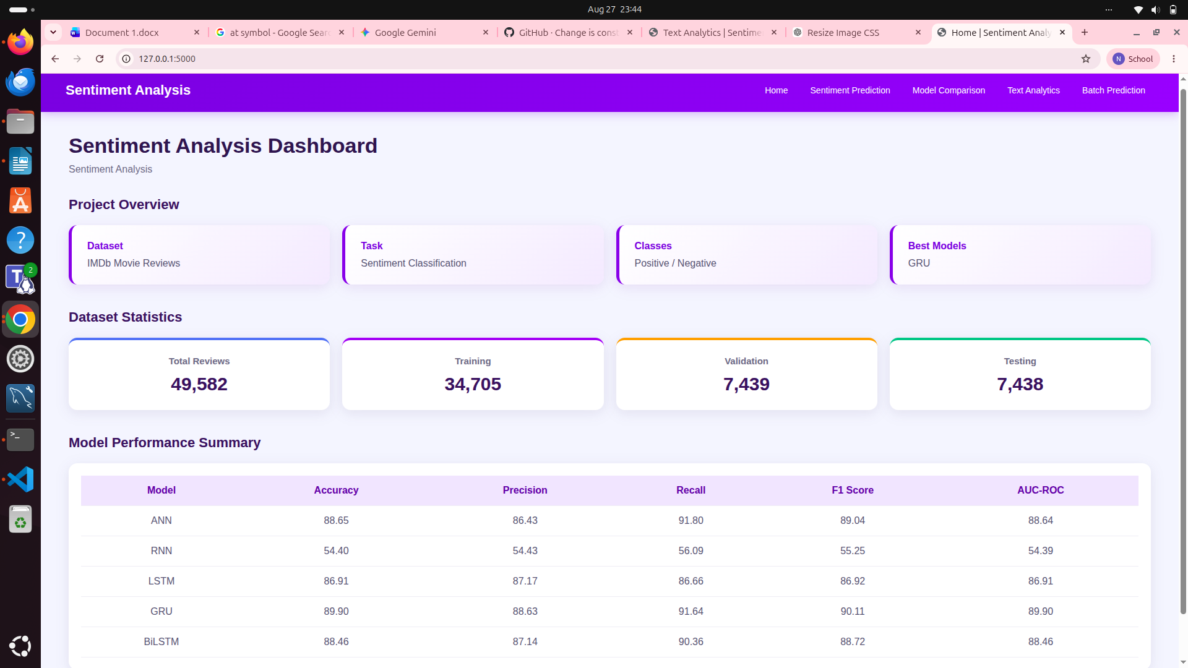

Dash Board Fig 5
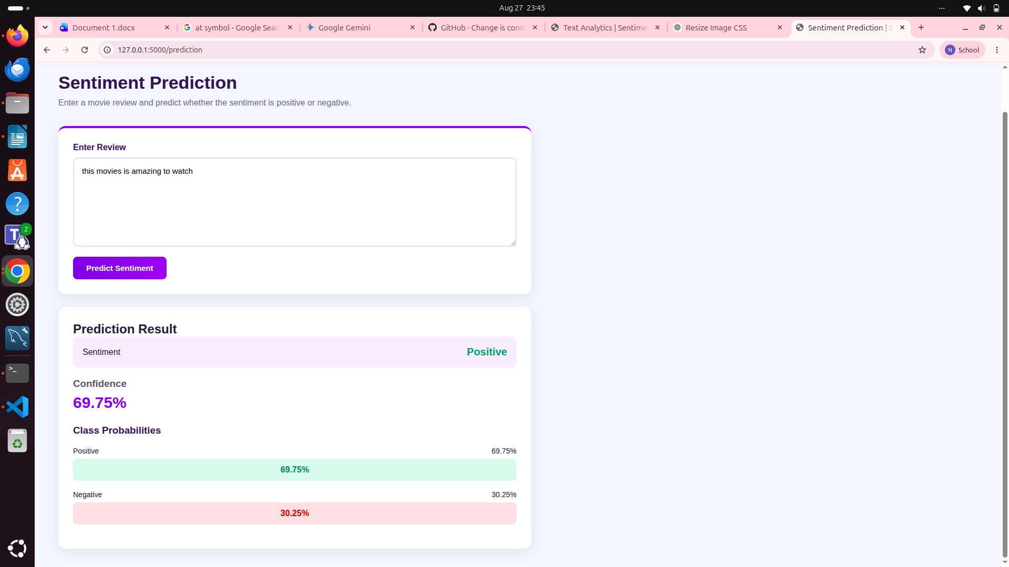

Sentiment Prediction Fig 6

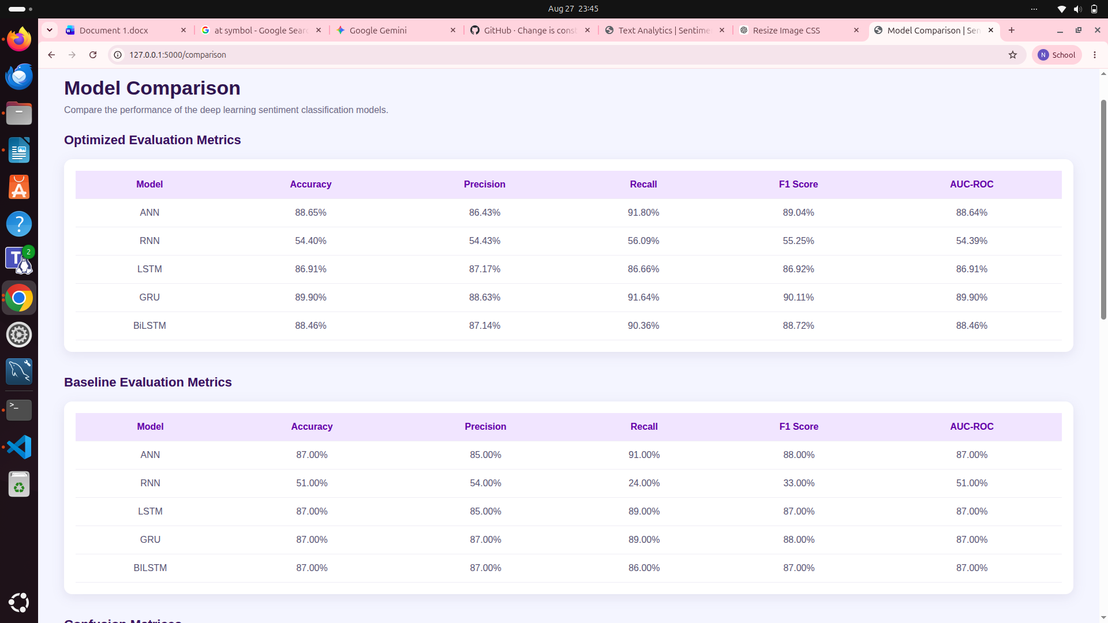

Model Comparison Fig 7
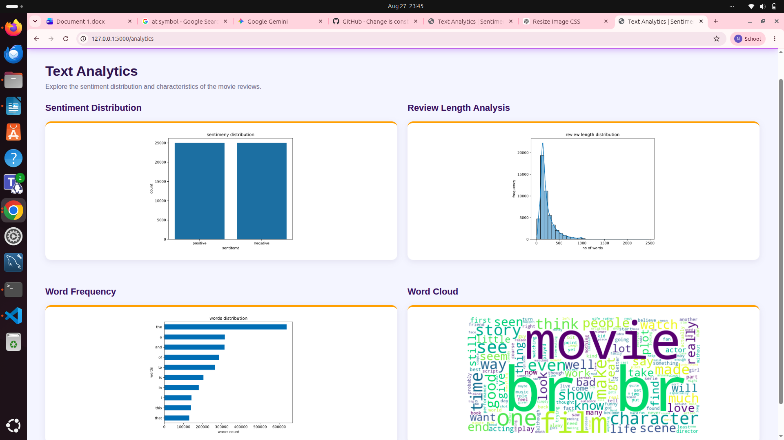

Text Analytics Fig 8

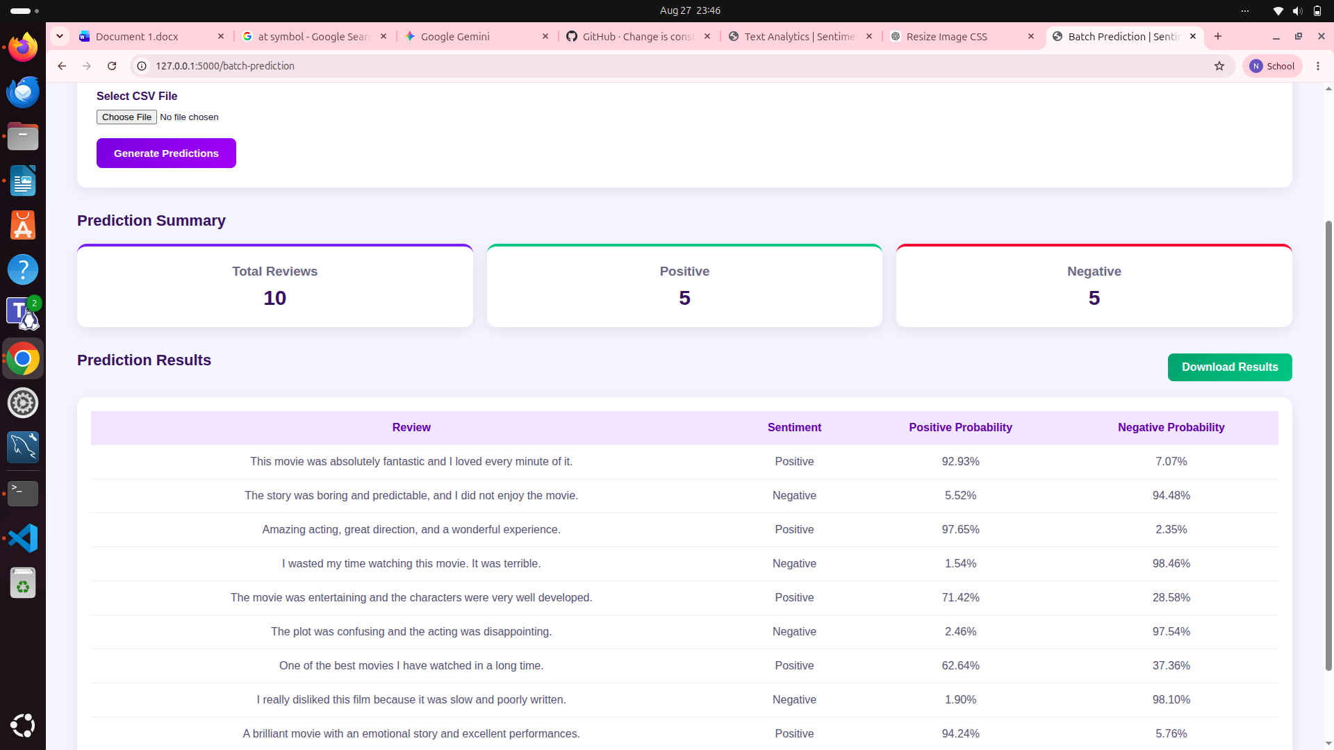

Batch Prediction Fig 9

